SEISMIC EVENT PREDICTION

INTRODUCTION

This project aims to understand the occurrence of tsunami when an earthquake hit based on the geographical location and the magnitude of the earthquake. The dataset also provide information like intensity, distance from epicentre, azimuthal distance etc.

**Data dictionary**:

Earthquake Location: The general area or region where the earthquake occurred.Latitude: The geographic coordinate that specifies the north-south position of the earthquake epicenter.Longitude: The geographic coordinate that specifies the east-west position of the earthquake epicenter.Affected Country: The country or countries that are impacted by the earthquake.Continent: The continent on which the earthquake occurred.Date and Time: The precise date and time when the earthquake occurred.Magnitude: The measure of the energy released at the source of the earthquake, commonly reported using the Richter scale or moment magnitude scale (Mw).Depth: The depth at which the earthquake occurred below the earth’s surface, usually measured in kilometers.Tsunami: Indicates whether the earthquake generated a tsunami.Reported Intensity: The perceived intensity of the earthquake as reported by people and observations, often using the Modified Mercalli Intensity (MMI) scale.Instrumental Intensity: The intensity of the earthquake measured using instruments, reflecting ground shaking levels.Alert Issued: Whether an official alert or warning was issued for the earthquake.Significance: A qualitative measure of the earthquake's impact, taking into account factors like population exposure and potential damage.Data Contributor: The organization or entity that provided the earthquake data.Seismic Station Used: The specific seismic station(s) that recorded the earthquake.Distance Between Station and Epicentre: The distance from the seismic station to the earthquake epicenter.Azimuthal Gap Between Stations: The largest angle between stations used to locate the earthquake, which can affect the accuracy of the location.Estimation Method: The method or algorithms used to estimate the earthquake’s parameters (e.g., magnitude, depth).

**2. Importing libraries and loading data set:**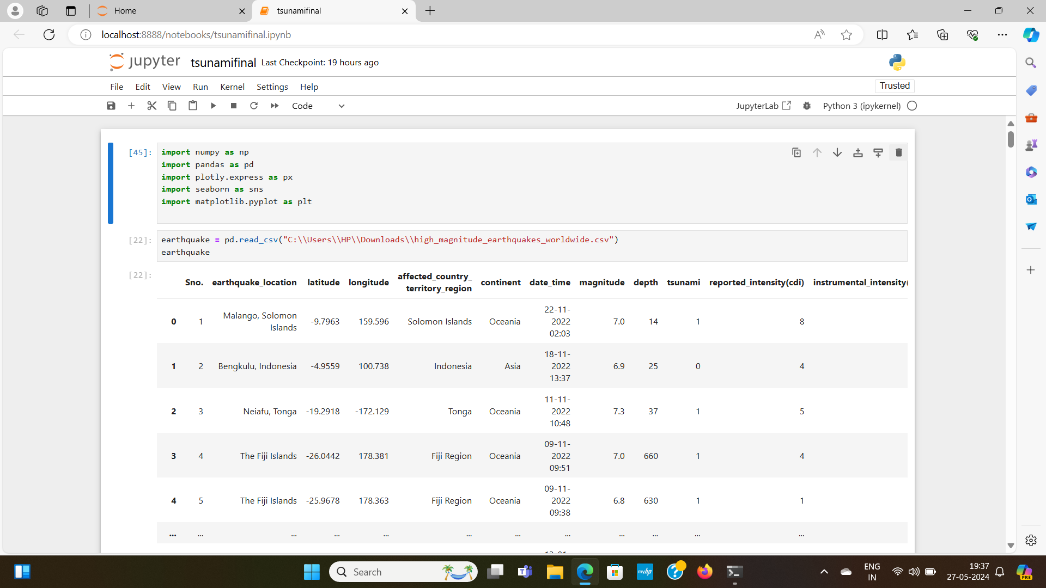

**3. Data Exploration**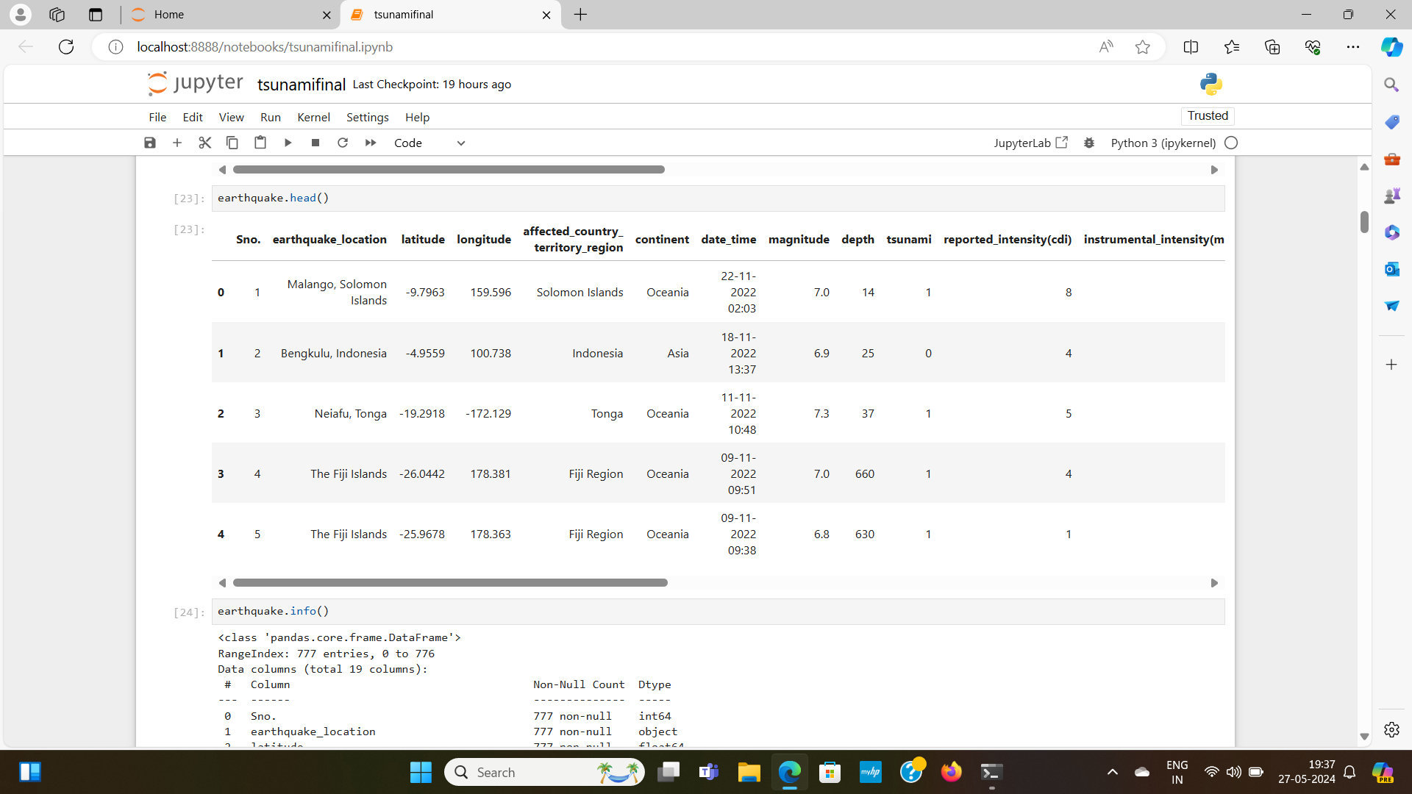

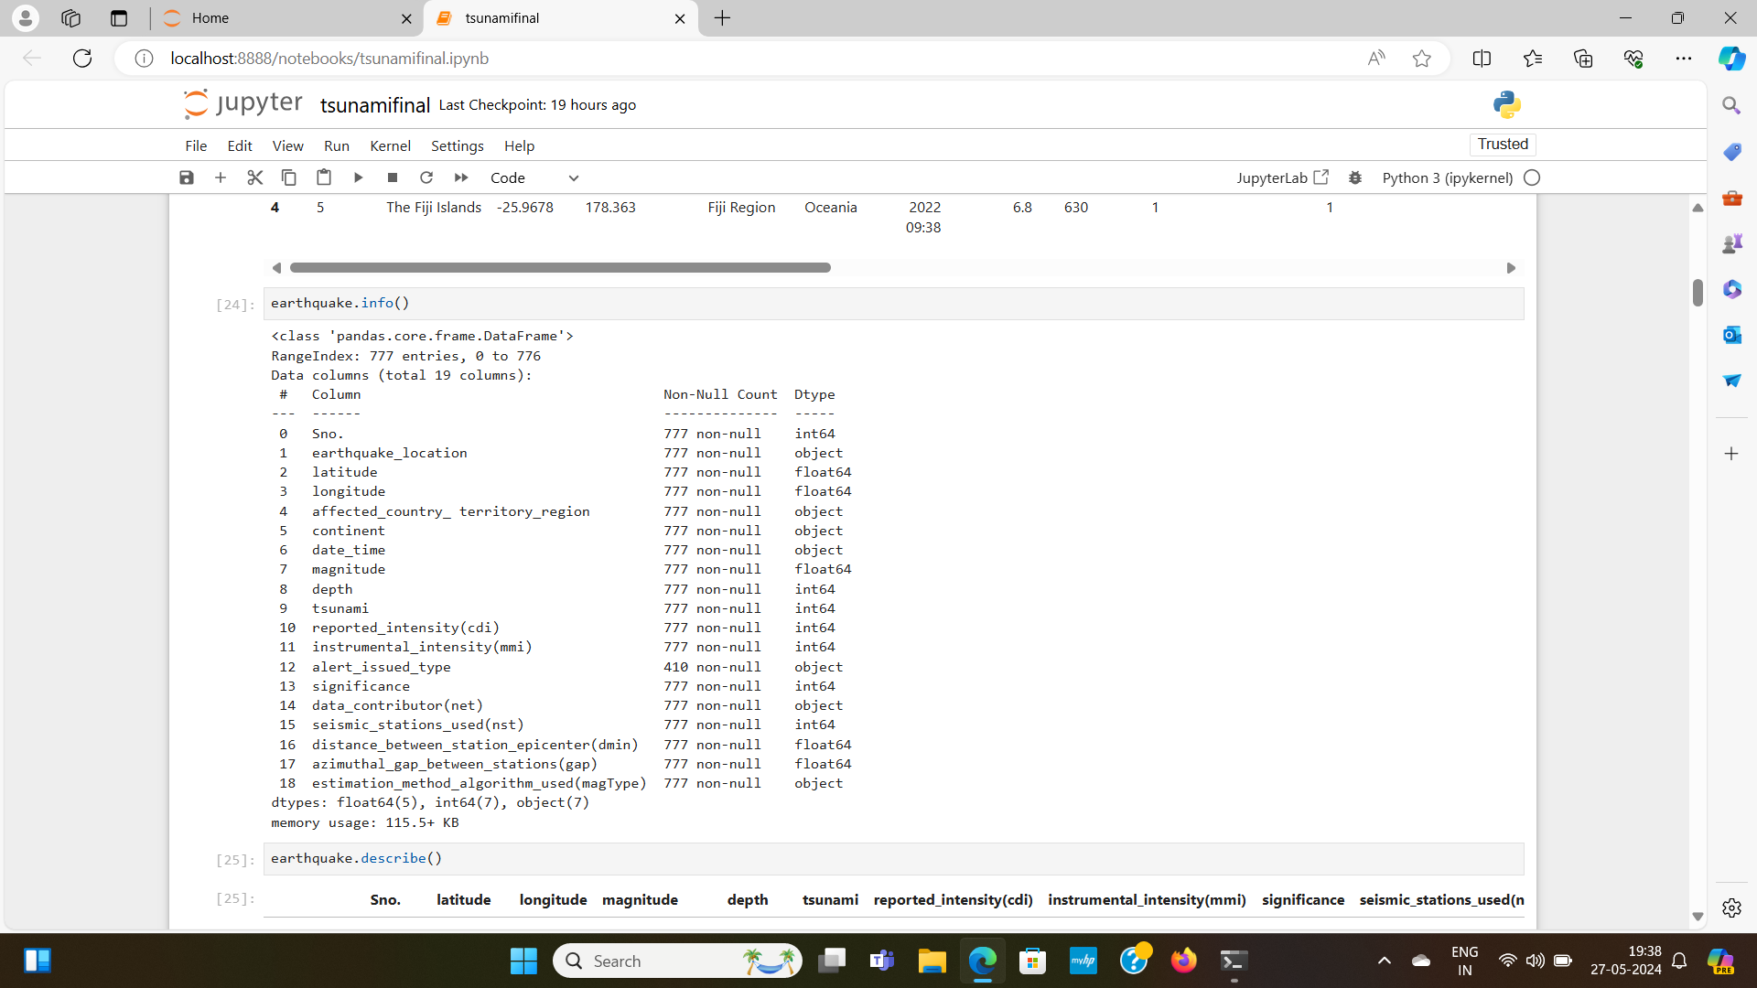

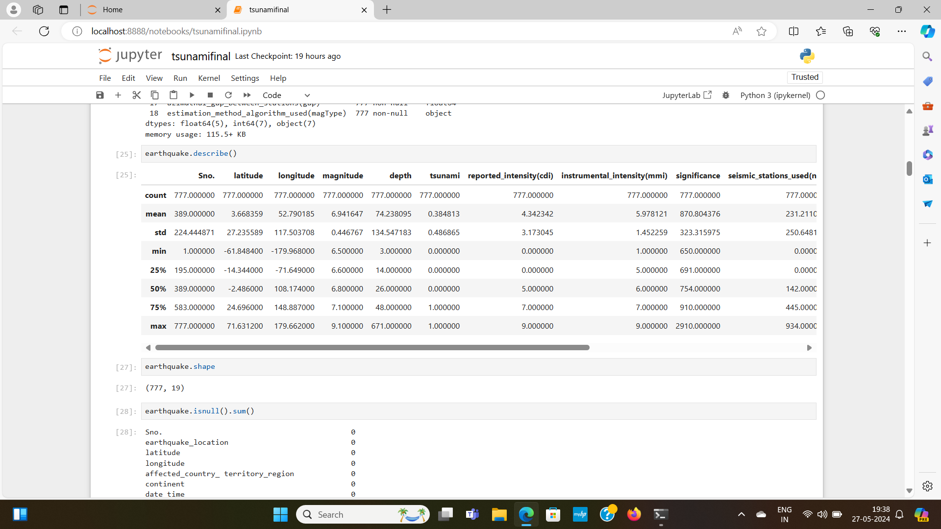

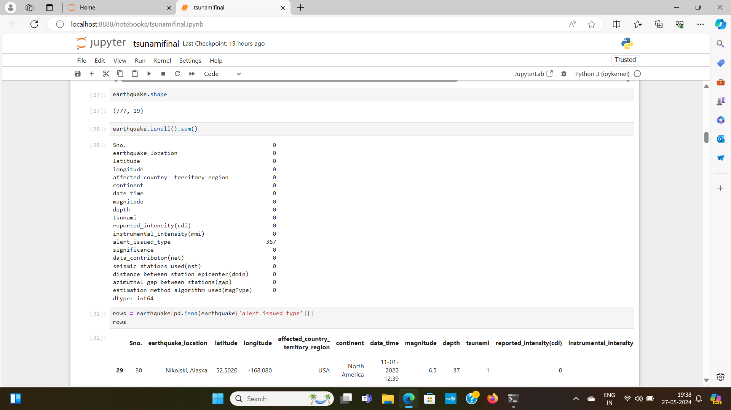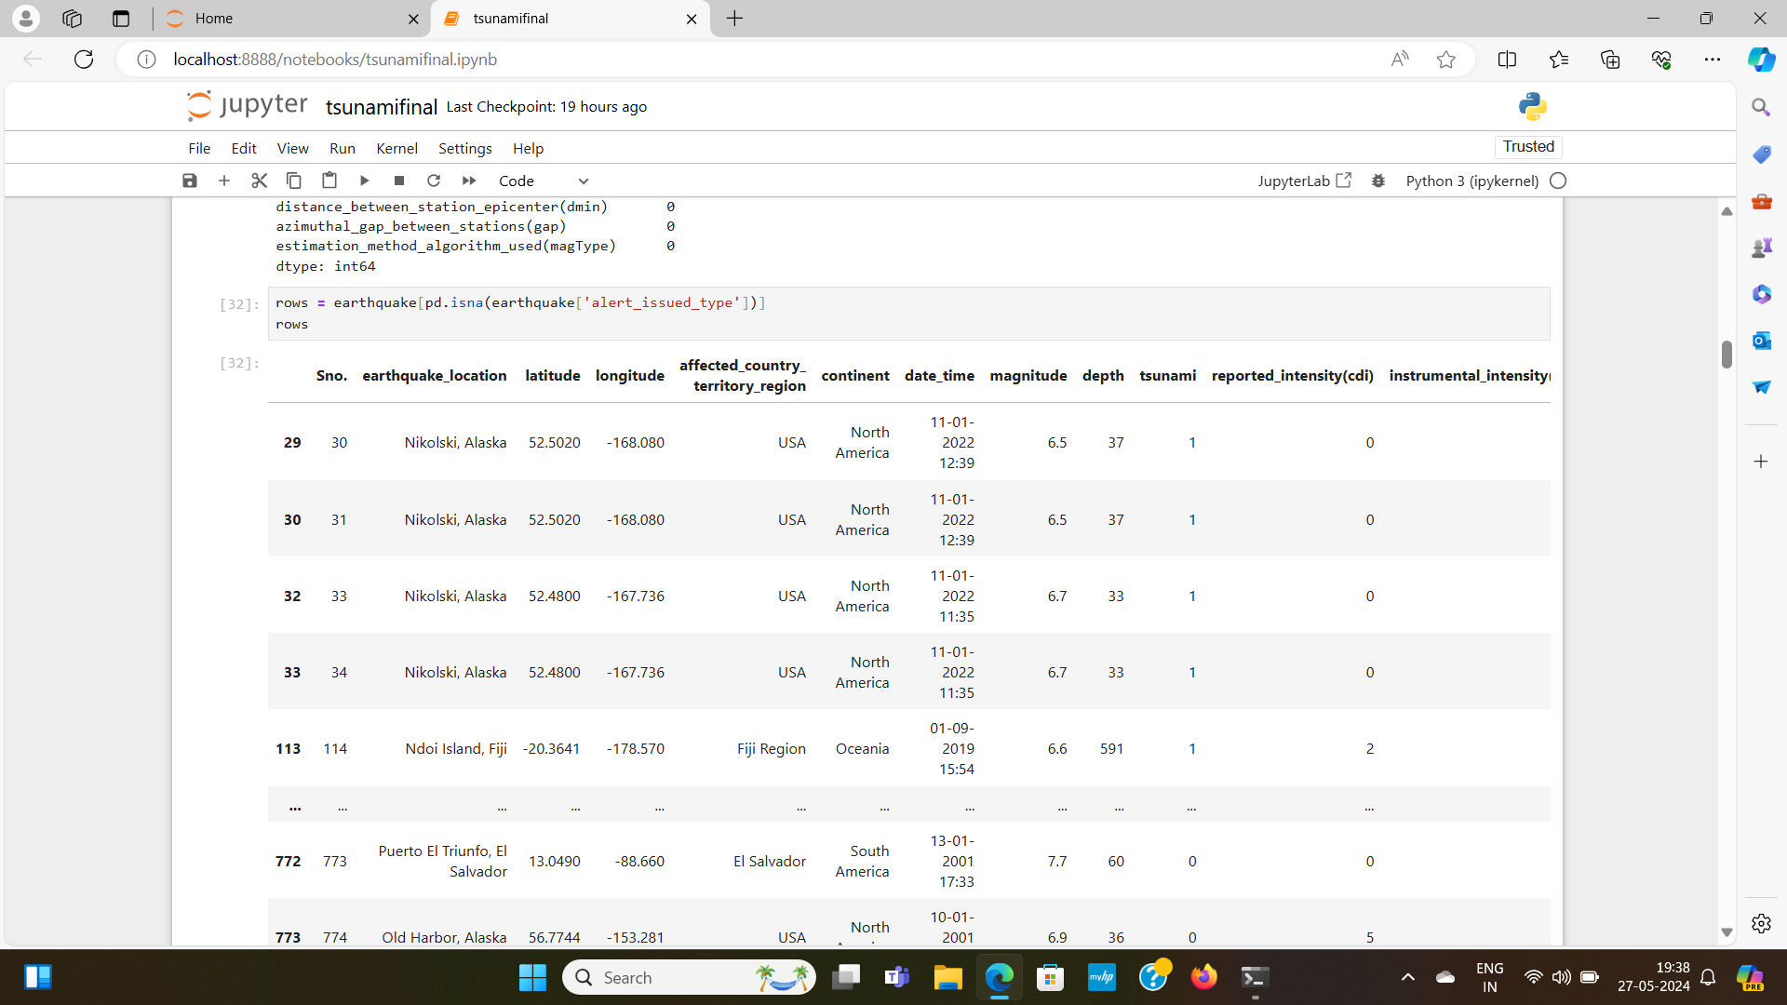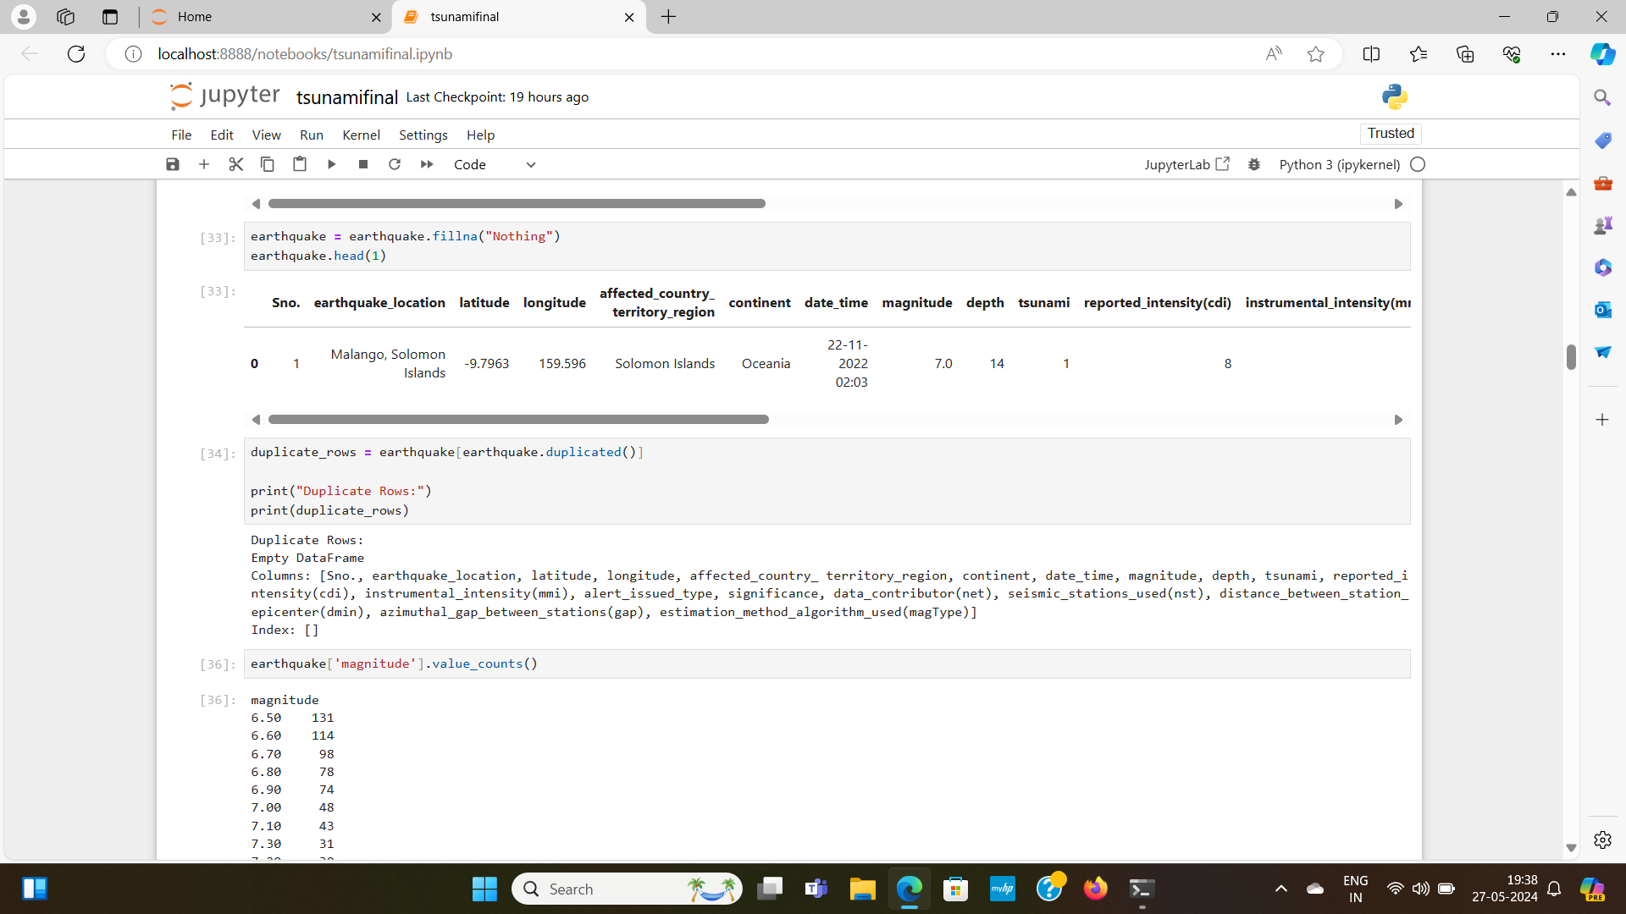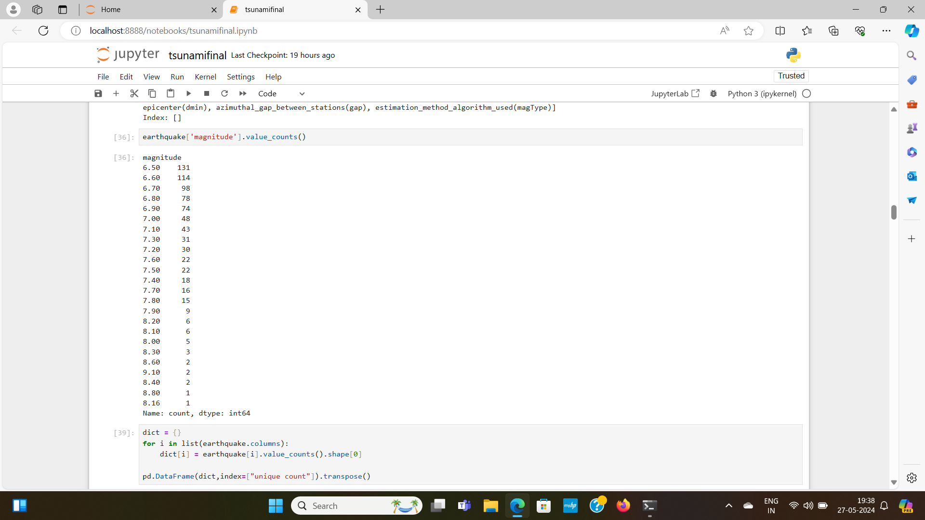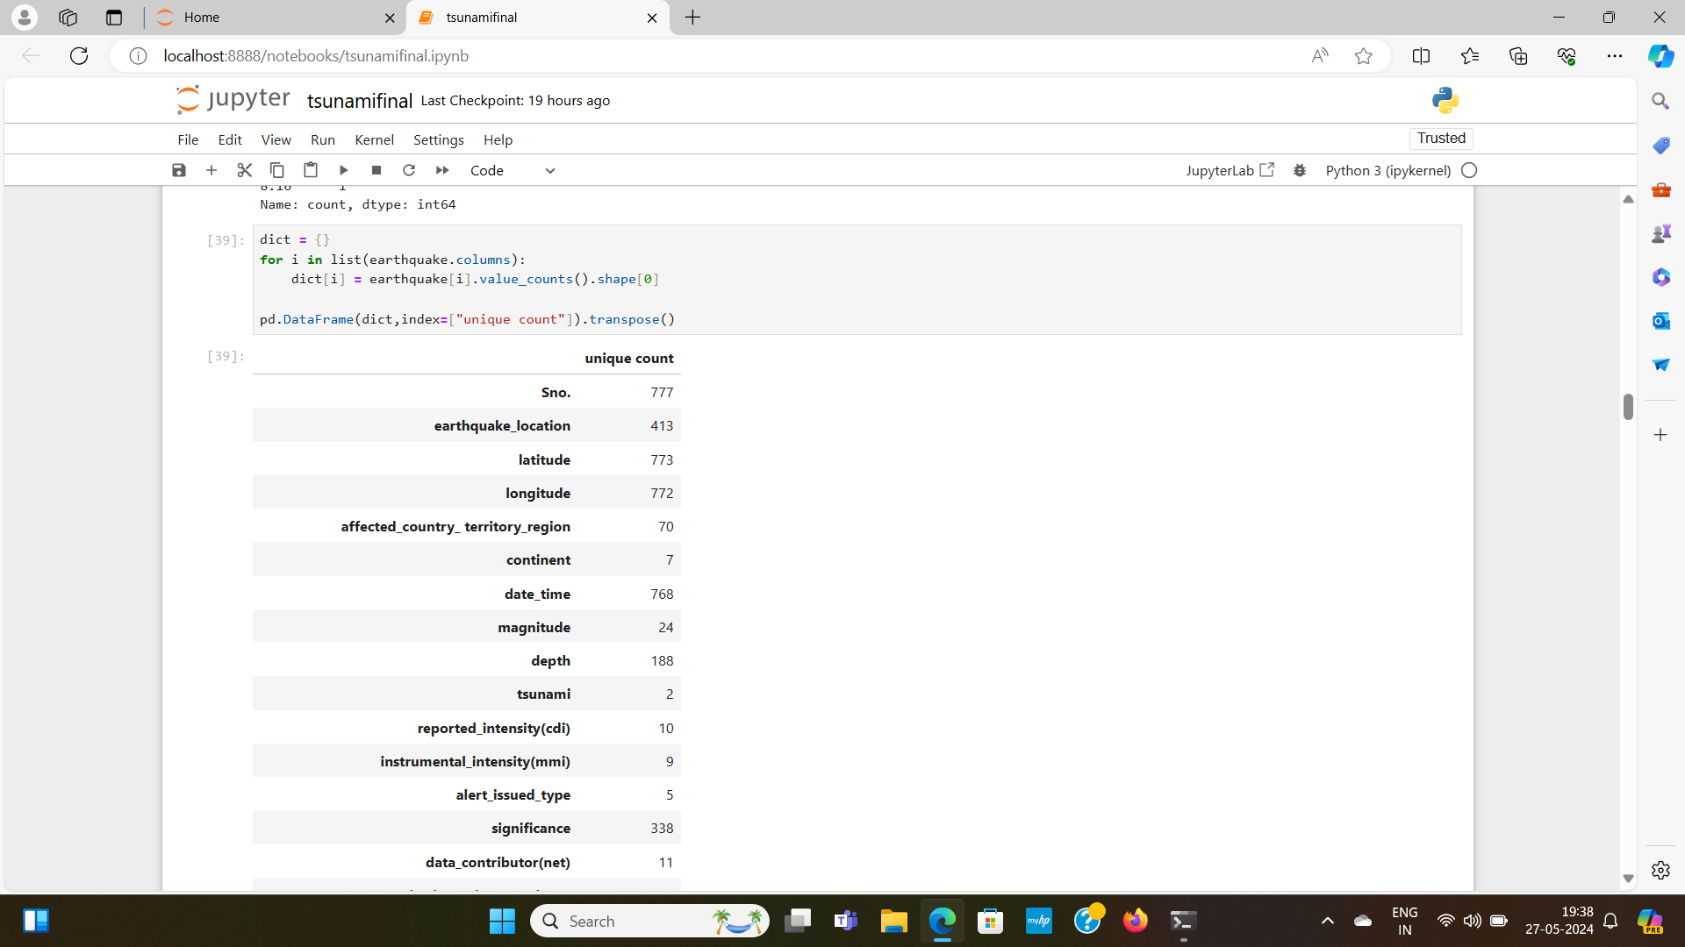

Label Encoding:

The dataset has categorical values, this step would remove that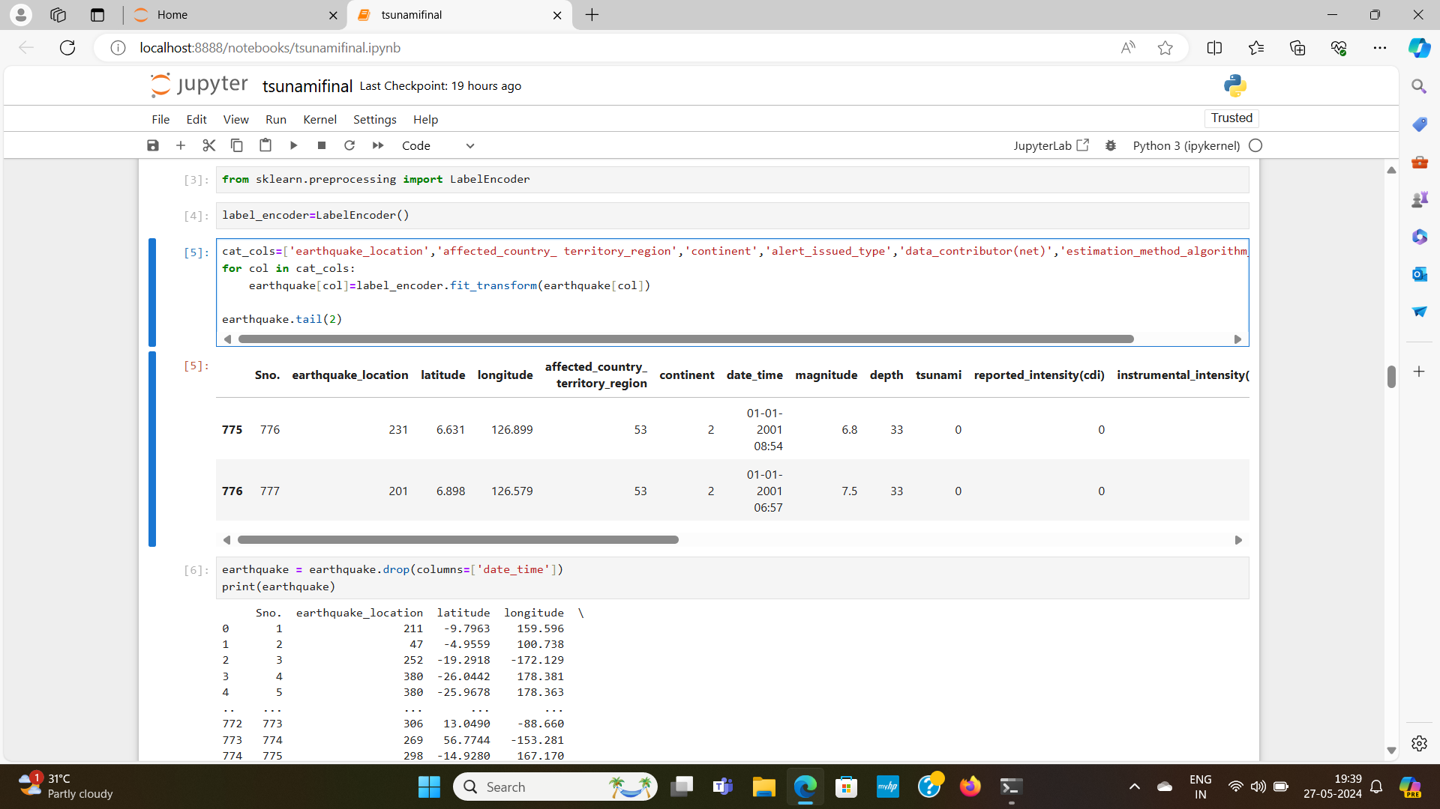

**4. Data Visualisation:**

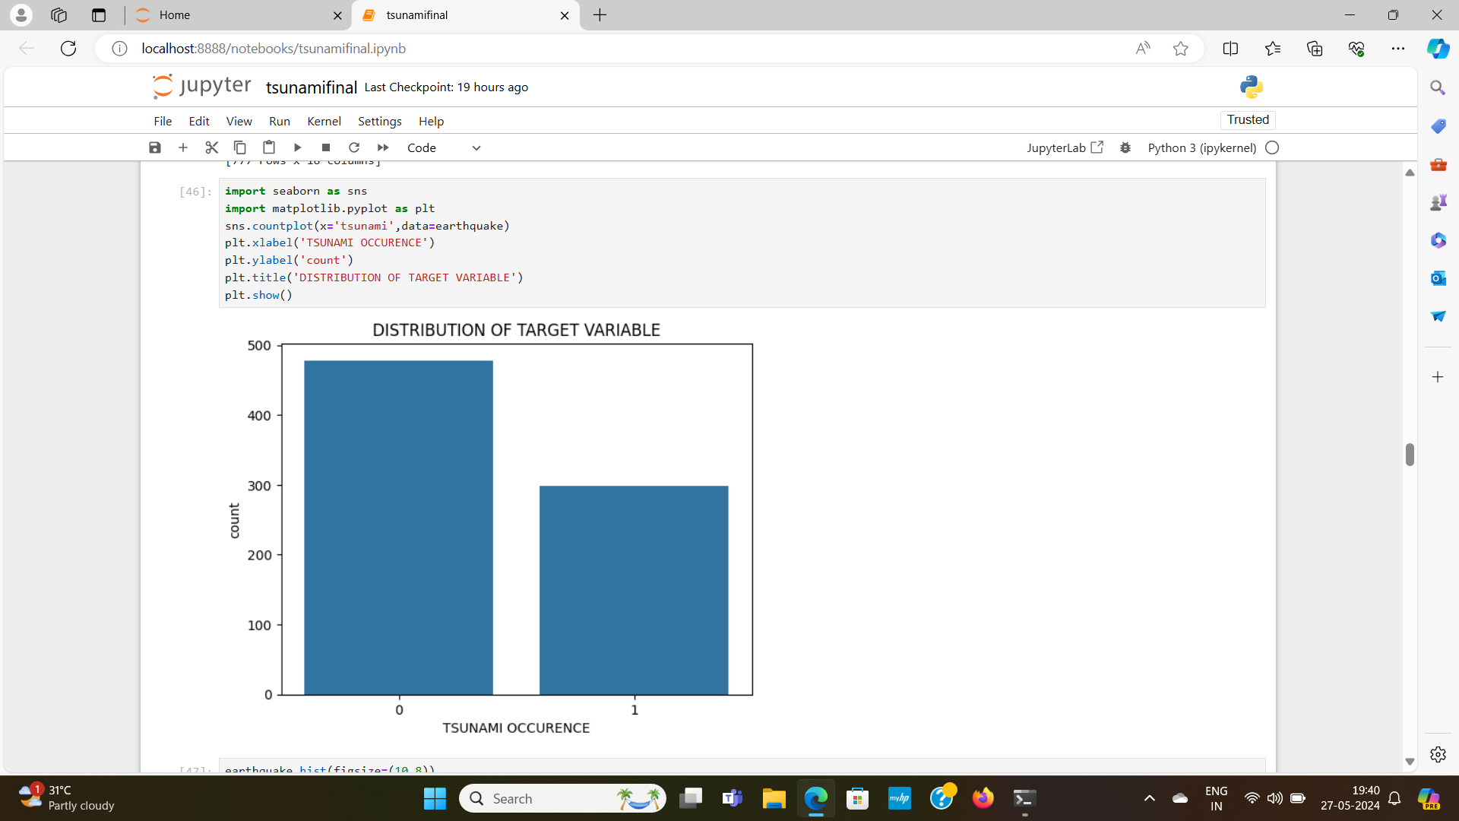

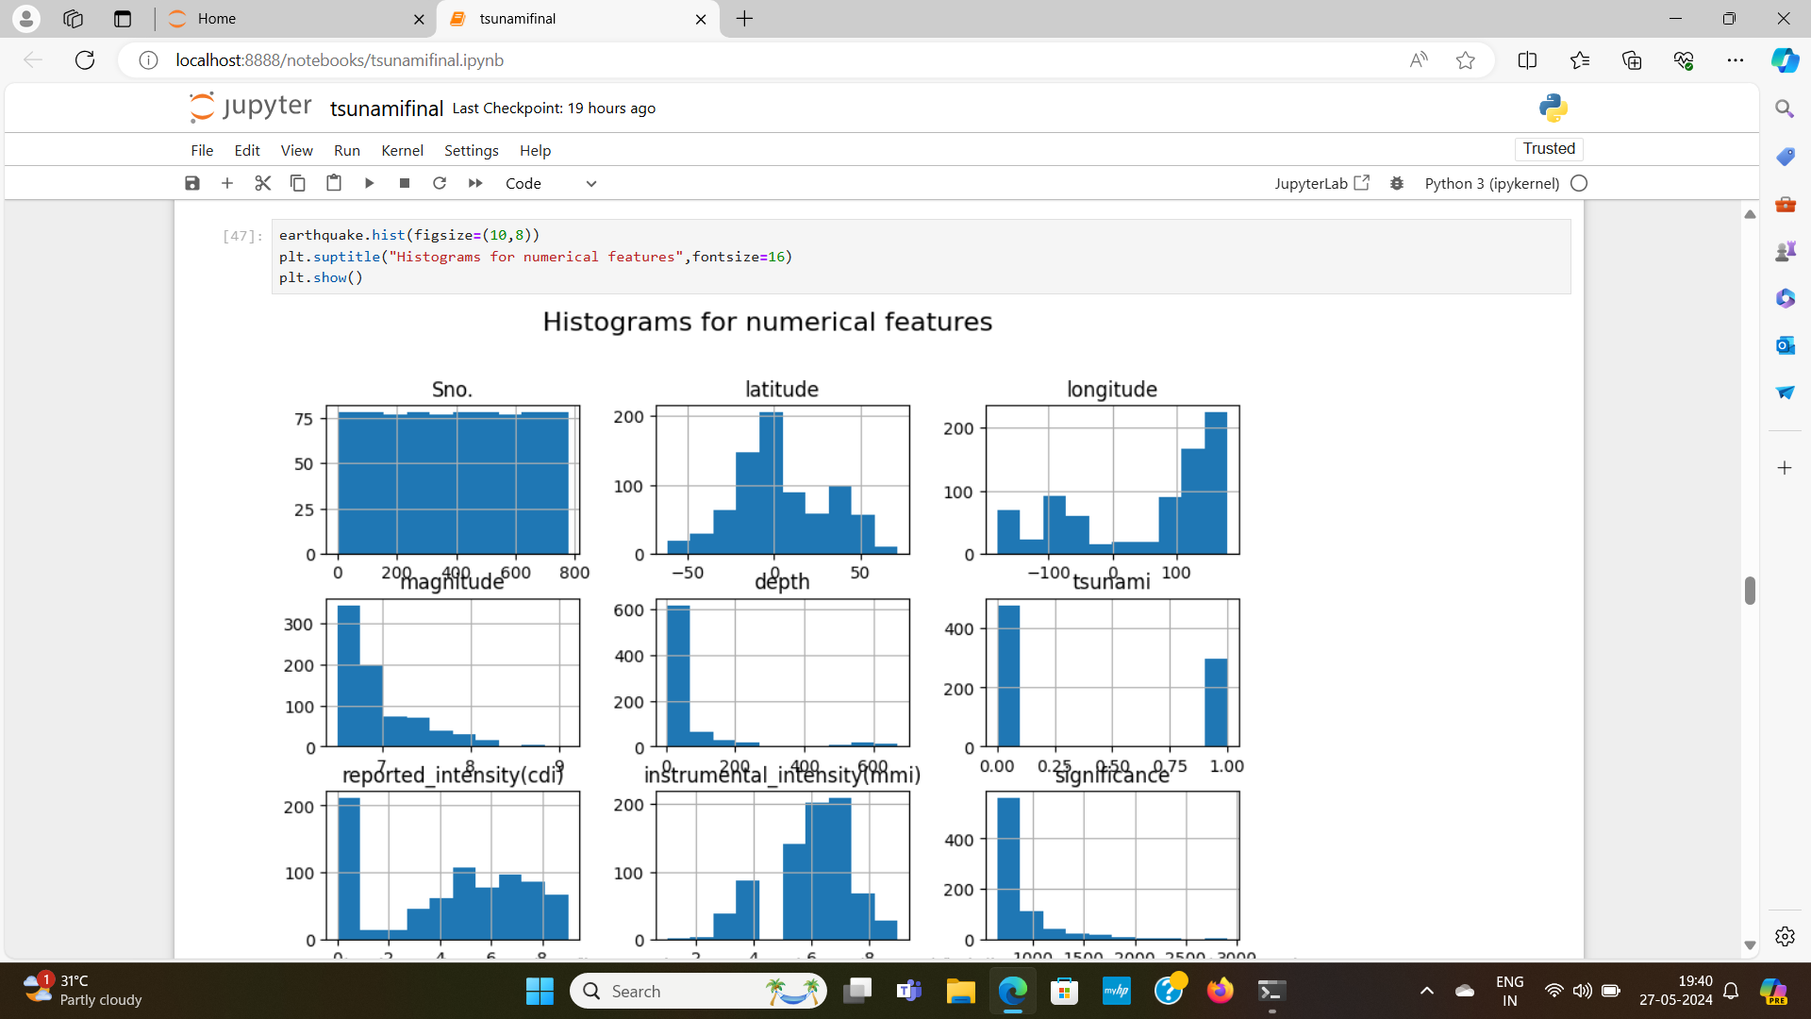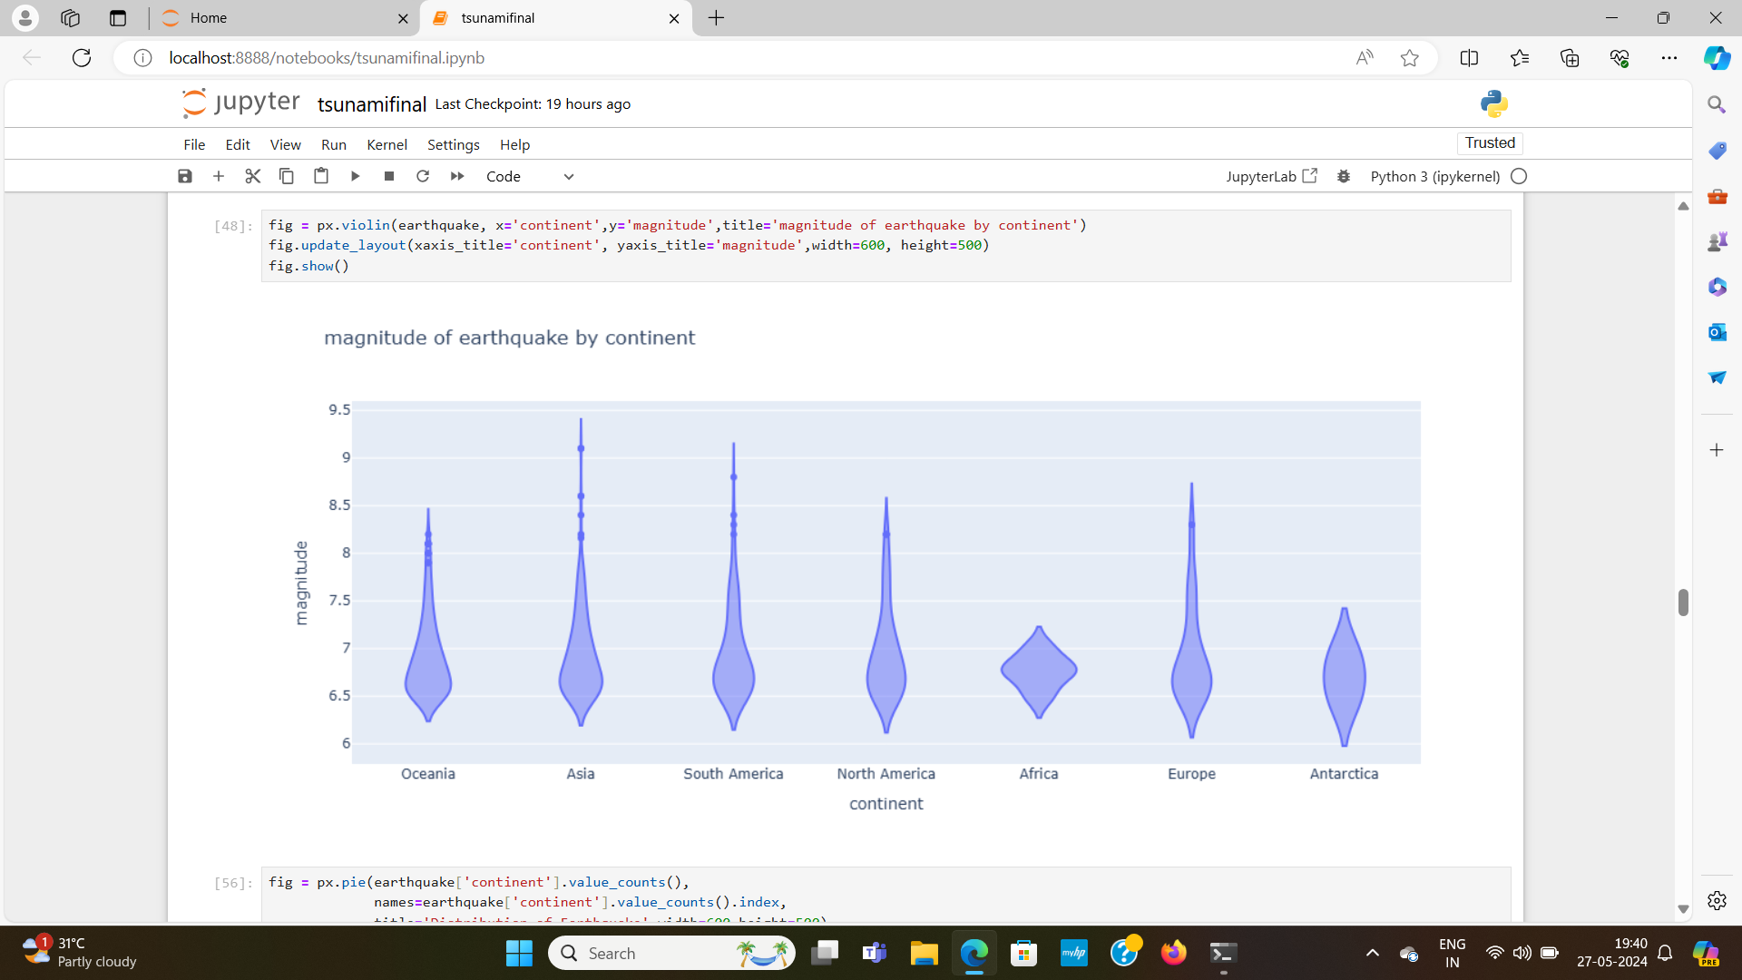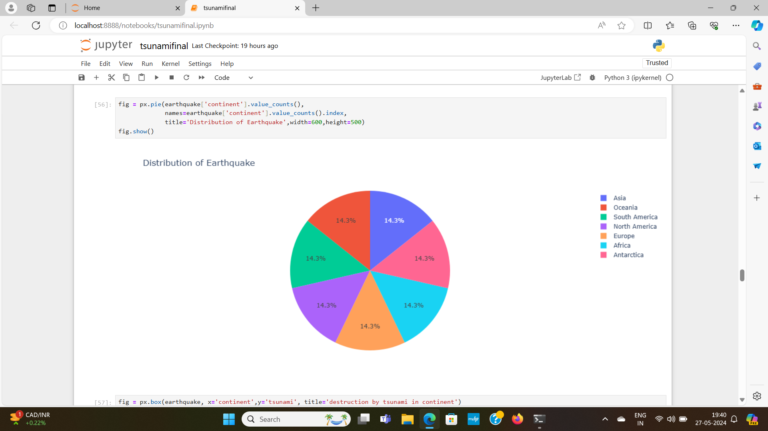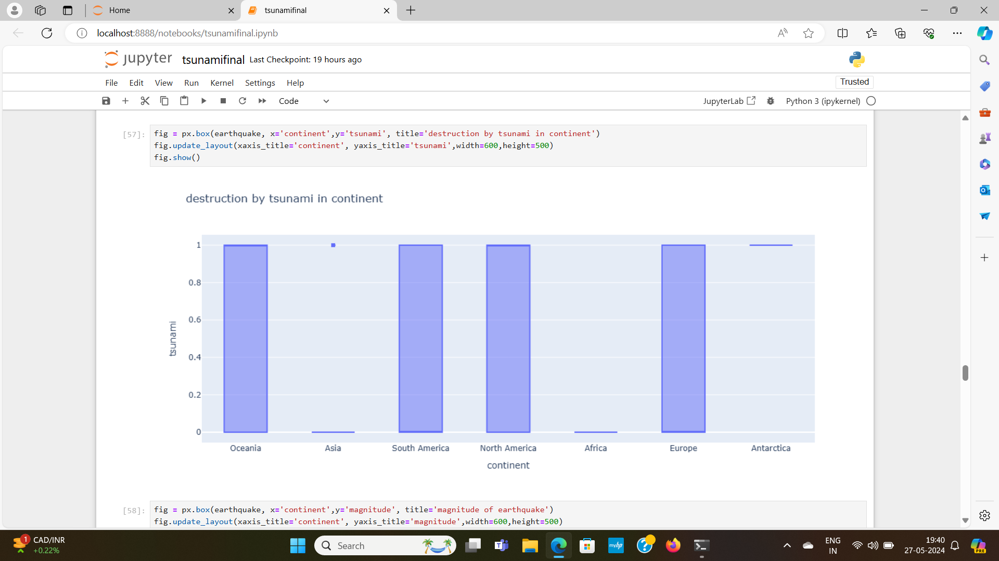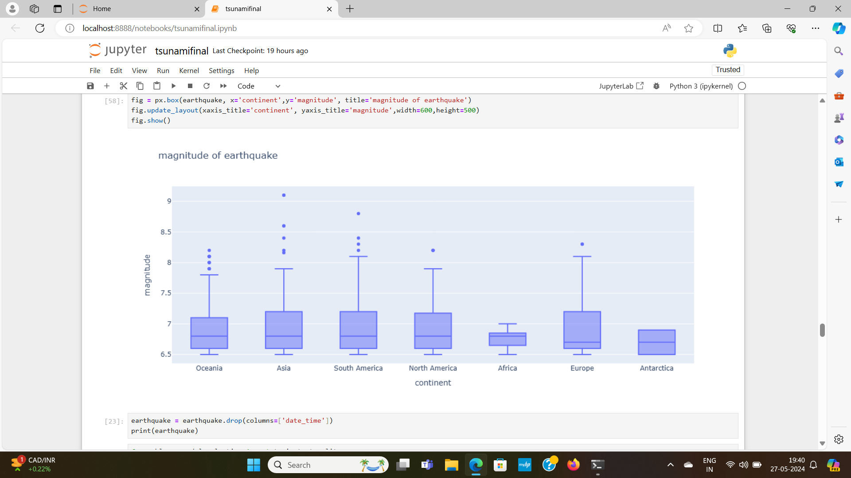

**5. Importing modules and packages**

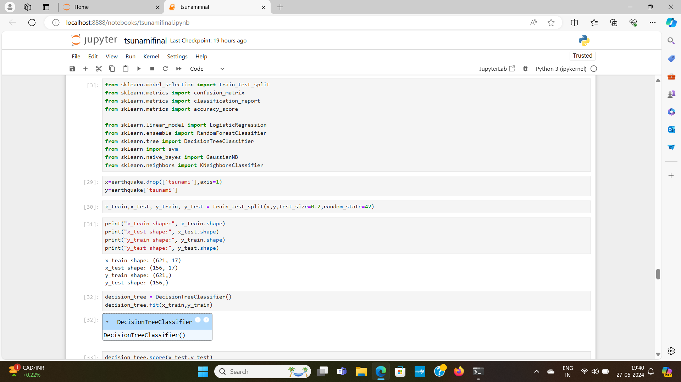

**Data preparation:**



1. Logistic Regression

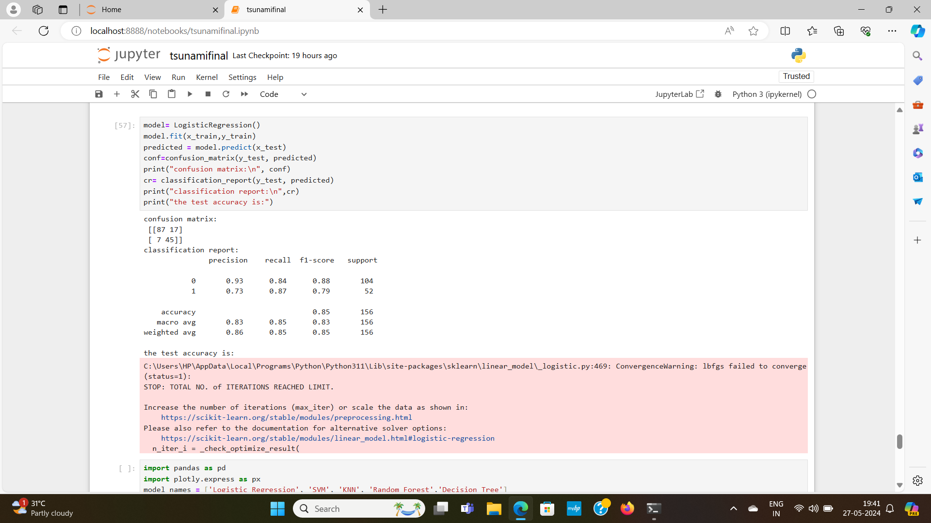

B. Support Vector Mechanism: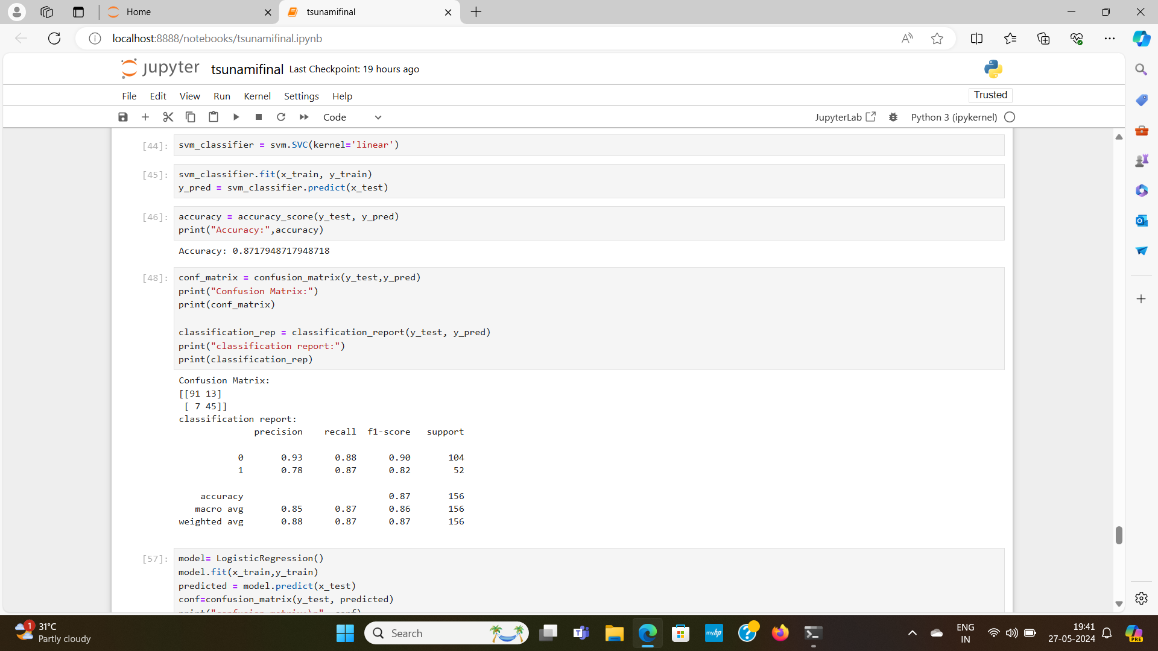

C. KNN Classifier:

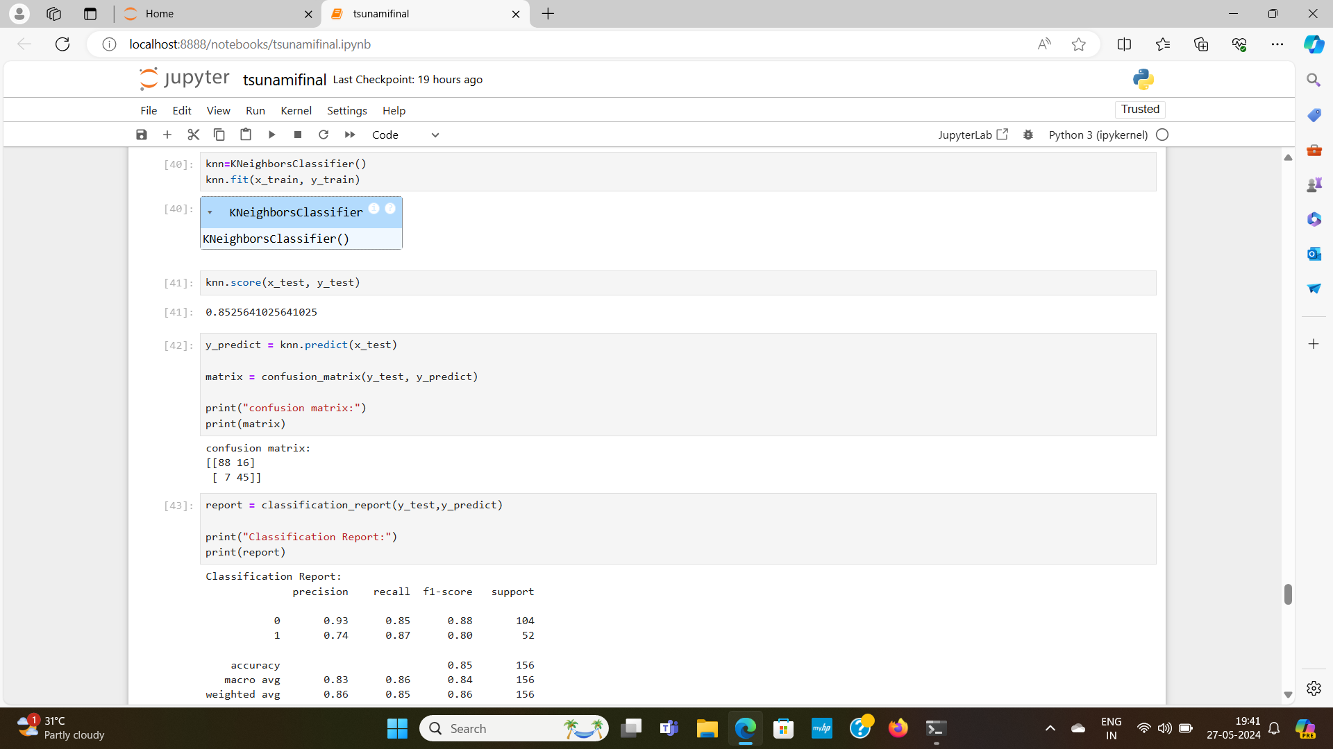

D. Random Forest Classifier

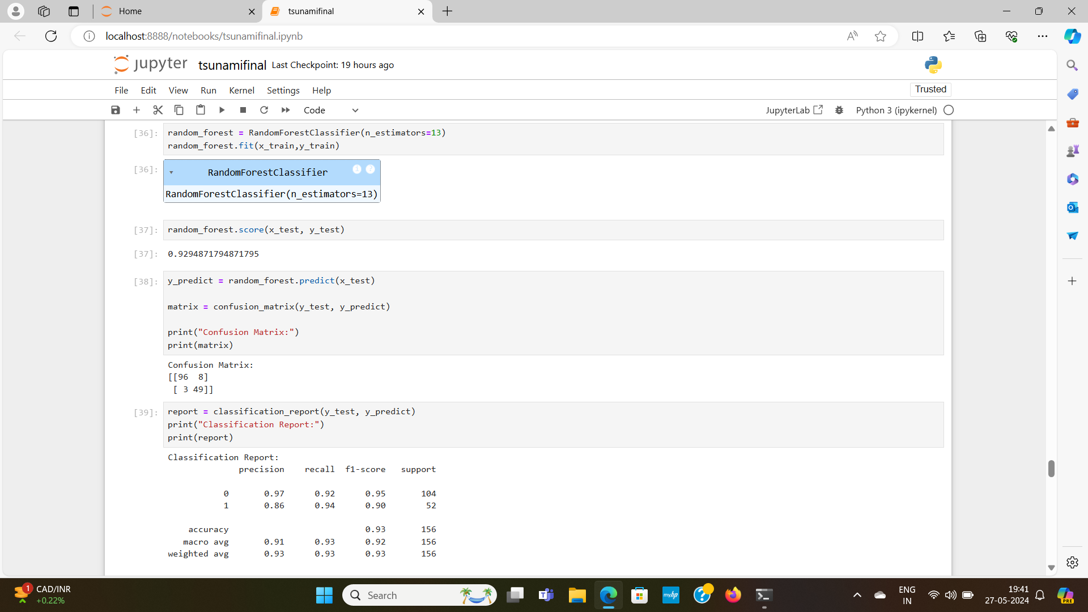

E. Decision Tree

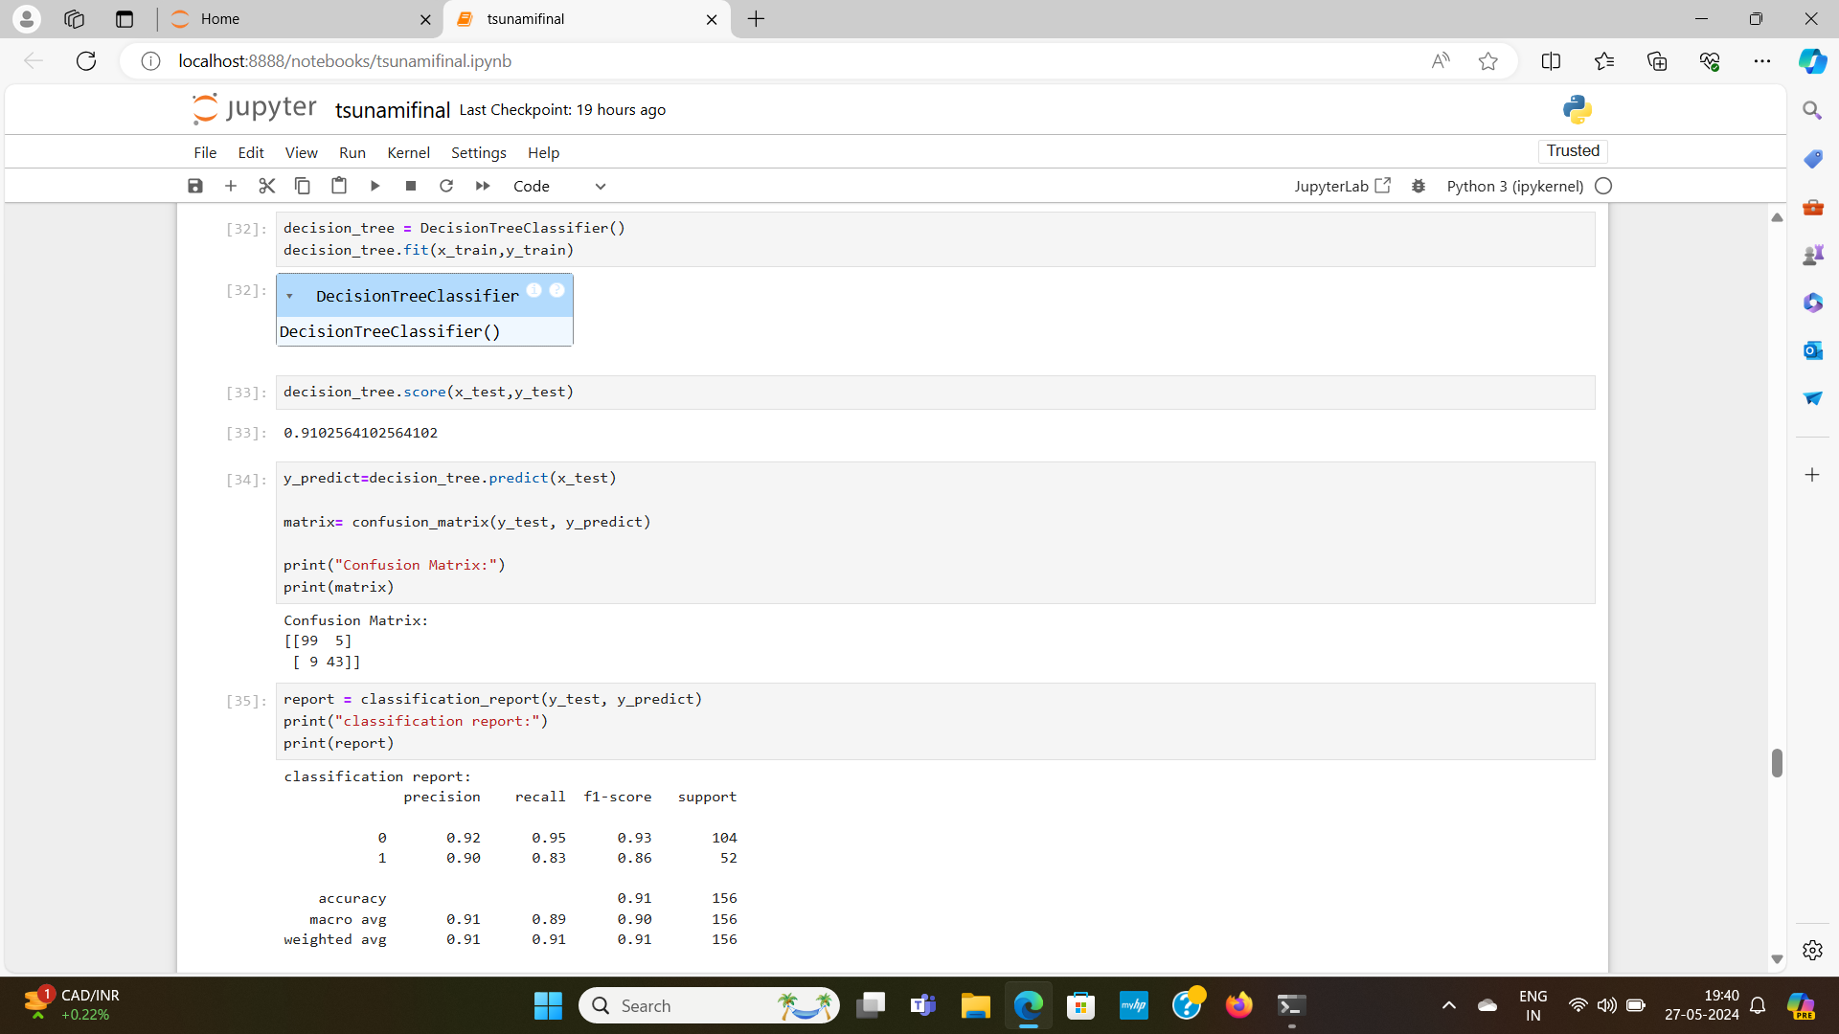

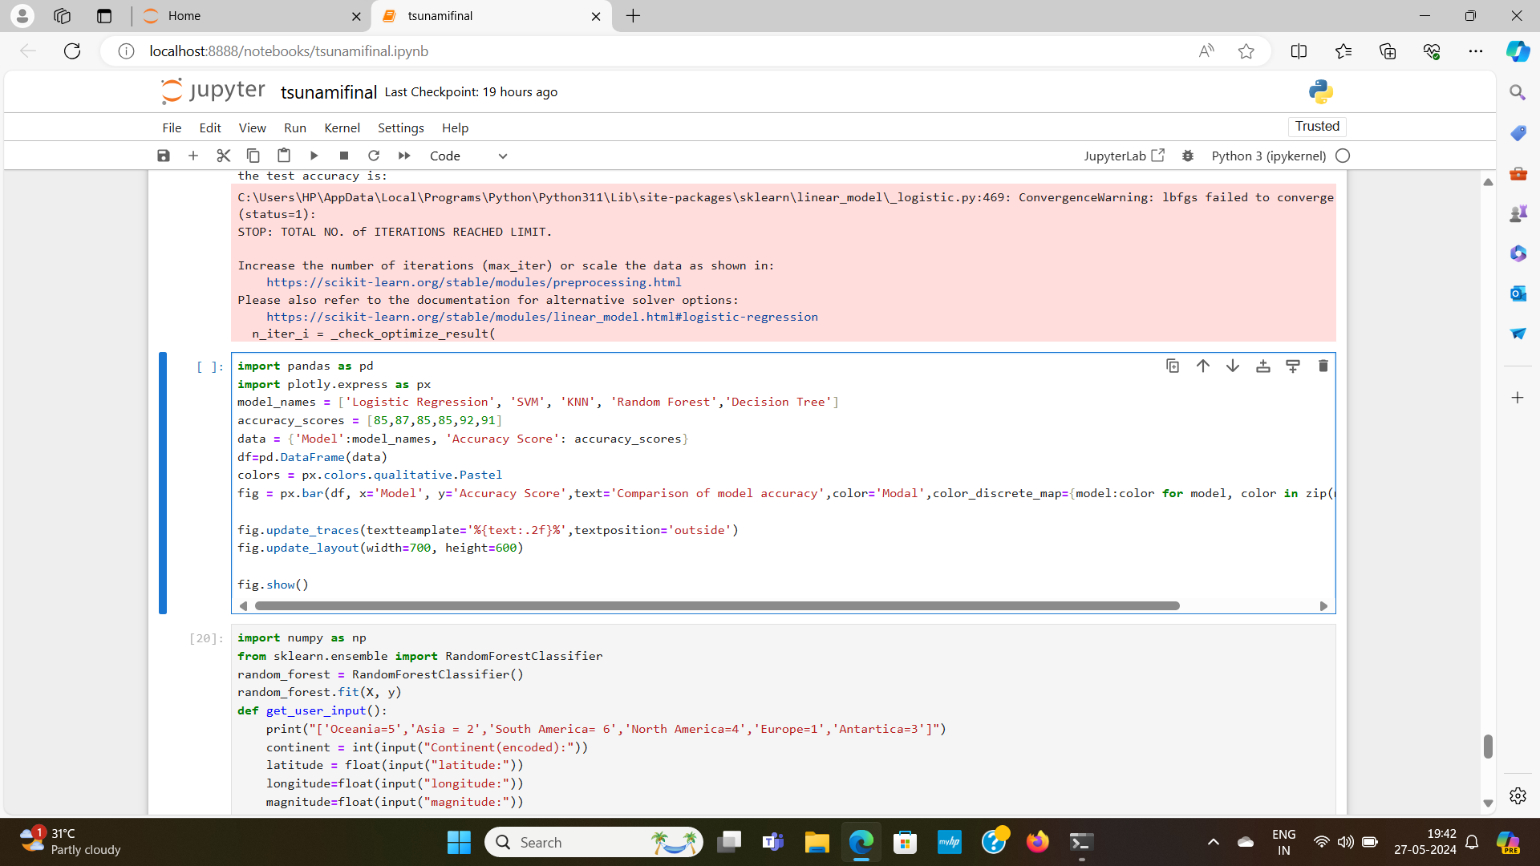

**Conclusion**

The Random Forest classifier and Decision TREE models emerged to be the top performers, performing good accuracy.

